Funds of Knowledge Survey
Skills

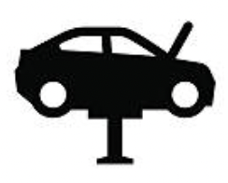 | 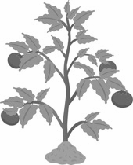 | 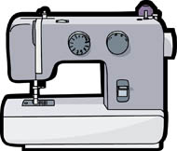
_______________ | _______________ | _______________
 | 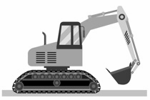 | 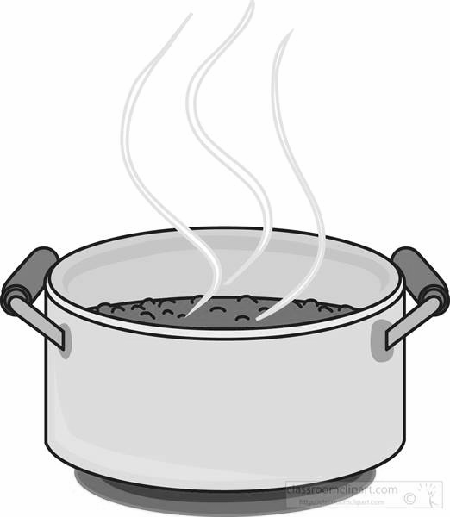
_______________ | _______________ | _______________
_______________ | _______________ | _______________
_______________ | _______________ | _______________
_______________ | _______________ | _______________
_______________ | _______________ | _______________
_______________ | _______________ | _______________

Funds of Knowledge Survey
What skills are there in your family?

- __________________________________________________
- __________________________________________________
- __________________________________________________
- __________________________________________________
- __________________________________________________
- __________________________________________________
- __________________________________________________
- __________________________________________________
- __________________________________________________
- __________________________________________________
- __________________________________________________
- __________________________________________________
- __________________________________________________
- __________________________________________________
- __________________________________________________
- __________________________________________________
- __________________________________________________

